**TRANS-CHAT : BREAKING LANGUAGE BARRIERS**

*A PROJECT REPORT*

Submitted to

**DR. A.P.J. ABDUL KALAM TECHNICAL UNIVERSITY**

*By*

**Aaditya Tyagi 1902290130001**

**Hardik Aggarwal 1902290100016**

**Kavya Tyagi 1902290100023**

**Ritik Sharma 1902290100043**

**Priya Kishore 1902290100034**

**Under the guidance**

**of**

**PUSHPENDRA KUMAR DWIVEDI**

*Submitted in fulfillment for the award of the degree*

*of*

**BACHELOR OF TECHNOLOGY**

*in*

**COMPUTER SCIENCE AND ENGINEERING**



**DEPARTMENT OF COMPUTER SCIENCE AND ENGINEERING**

**VIDYA COLLEGE OF ENGINEERING,MEERUT**

**2022-2023**

**DECLARATION**

We hereby declare that this submission is our work and that, to the best of our knowledge and belief, it contains no material previously published or written by another person nor material which to a substantial extent has been accepted for the award of any other degree or diploma of the university or other institute of higher learning, except where due acknowledgement has been made in the text.

**Signature of Students**

Name: Aaditya Tyagi

Roll No.: 1902290130001

Name: Hardik Aggarwal

Roll No.: 1902290100016

Name: Kavya Tyagi

Roll No.: 1902290100023

Name: Ritik Sharma

Roll No.: 190229100043

Name: Priya Kishore

Roll No.: 1902290100034

**CERTIFICATE FROM COLLEGE**

This is to certify that Project Synopsis entitled “**Trans-Chat: Breaking Language Barriers**” which is submitted by  **Aaditya Tyagi, Kavya Tyagi, Hardik Aggarwal, Ritik Sharm** & **Priya Kishore** in partial fulfillment of the requirement for the award of degree **Bachelor Of Technology** to **Vidya College of Engineering** is an authentic Work carried out by them under my supervision. The matter embodied in this Project work is original and has not been submitted for the award of any degree or diploma to the best of any knowledge and belief.

**Date: Supervisor Signature**

Mr. Pushpendra Dwivedi

(HOD)

**ACKNOWLEDGEMENT**

We would like to sincerely thank our mentors, **Er. Pushpendra Kumar Dwivedi**, and **Mr.Sachin Kumar** from VIDYA **COLLEGE OF ENGINEERING, VKP, Meerut**, for their invaluable guidance and support throughout our project on **"Trans chat: Breaking language barriers"** Their constant motivation, insightful suggestions, and unwavering assistance have been instrumental in the successful completion of this report. We are truly grateful for their mentorship.

We also extend our gratitude to the **faculty members of the department** for their valuable

assistance and cooperation during the development of our project. Their expertise and

willingness to help have significantly contributed to shaping our work.

We acknowledge the significant contributions of our friends who have supported us

throughout the project. Their collaboration and encouragement have been invaluable.

Finally, we would like to express our heartfelt appreciation to **Director VCE Dr. Rajiv**

**Kumar Chechi and Dean Er. Ashwani Vashishtha** for their continuous support and guidance.

Their vision and leadership have created an environment conducive to academic and research

excellence.

We would like to thank everyone who has contributed to the successful completion of this

project. Your dedication, guidance, and support have been instrumental, and we are sincerely

grateful for your contributions.

**Signature of Students**

**Name: Aaditya Tyagi Name : Priya Kishore**

Roll No.: 1902290130001 Roll No :1902290100034

**Name: Kavya Tyagi Name: Hardik Aggarwal**

Roll No.: 1902290100023 Roll No.: 1902290100016

**Name: Ritik Sharma**

Roll No.: 190229100043

**ABSTRACT**

In today’s era , where the world of online communication has acquired a significant place in everyone’s life , Language barriers have always been a challenge in order to achieve a seamless communication BUT no more as **TRANS-CHAT** is a game-changing technology that has the ability to break down language barriers and connect individuals from all over the world. TRANS-CHAT has an easy-to-use UI that is accessible to users of different technological backgrounds and skill levels. **TRANS-CHAT** offers an effective way to break the language barrier, regardless of whether you're a company professional doing international Work, a tourist discovering new cultures, or just an individual trying to interact with people around the world.

**TRANS-CHAT** aims to change the way people communicate , providing the new way individuals and businesses could connect , collaborate and make a strong bond easily , regardless of whichever languages they speak.

The time of using Translators and chat application separately for different purpose is now over as **TRANS-CHAT** provides functionality of both Translators and chat application as a single application only helping individuals by reducing wastage of time and creating a seamless experience for the users.

A large number of most popular languages spoken around the world are supported by **TRANS-CHAT**. No matter where you are or who you are speaking to, **TRANS-CHAT** aims at providing users with the application using which users can communicate easily in their preferred language, including English, Spanish, Mandarin, French, German, Arabic, and many more.

**LIST OF FIGURES**

| **S.No.** | **Figure name** | **Page No.** |
| --- | --- | --- |
| 1 | Data flow diagram 1 | 32 |
| 2 | Data flow diagram 2 | 32 |
| 3 | Cyber Punk theme | 33 |
| 4 | Login page | 34 |
| 5 | Signup page | 35 |
| 6 | Chat page | 36 |
| 7 | Available users panel | 37 |
| 8 | Sender and receiver selected | 38 |
| 9 | Message translation on both ends | 39 |
| 10 | Language selection view | 40 |
| 11 | Images sent | 41 |

**LIST OF ABBREVIATIONS**

API: Application Programming Interface

HTML: HyperText Markup Language

CSS: Cascading Style Sheets

JavaScript: Programming language

Node.js: Runtime environment

Firebase: Backend-as-a-service platform

CRUD: Create, Read, Update, Delete

UI: User Interface

UX: User Experience

JSX : JavaScript XML

NPM :Node Package Manager

JSON : JavaScript Object Notation

SDLC : Software Development Life Cycle

PNG : Portable Network Graphics

JPG/JPEG : Joint Photographic Expert Group

GIF : Graphics Interchange Format

**TABLE OF CONTENTS**

**DECLARATION…………………………………………...…………………………...……ii**

**CERTIFICATE…………………………………………………………………………..….iii**

**ACKNOWLEDGEMENT………………………………………………………………..…iv**

**ABSTRACT…………………………………………….………………………………….....v**

**LIST OF FIGURES……………………………………...………………………………….vi**

**LIST OF TABLES………………………………………..……………….………………..vii**

**.**

**LIST OF ABBREVIATIONS…………………………………………………….……….viii**

**CHAPTER 1: INTRODUCTION…………...…………………………………….……10-20**

1.1 Introduction…………………………………………...………………………………10-12

1.2 Problem Statement………………………………………………….……………………14

1.3 Methodology……………………………………………………………….…………….15

1.4 Objective…………………………………………………………………………………20

1.5 Use Case Chart……………………………………………………………………………21

**CHAPTER 2: LITERATURE REVIEW………………………………………………17-22**

**CHAPTER 3: METHODOLOGY AND FLOWCHART…………………..……...…23-24**

3.1 Methodology………………………………………………………………..…….…..23-24

3.2Flowchart………………………………………………………………………..………...26

**CHAPTER 4: TECHNOLOGIES USED……………………………………………...24-28**

4.1 Technology Used…………………………………………………………………………29

**CHAPTER 5: SYSTEM DESIGN……………………………………………….….….30-33**

5.1 System Design……………………………………………….…………………………...30

**CHAPTER 6: TESTING PART………………………………………………….…….34-35**

6.1 Testing and Maintenance…………………………………………………………………34

**CHAPTER 7: RESULTS………………………………………………….…………....36-39**

7.1 Results and Discussions………………………………………………….……………....36

**CONCLUSION AND FUTURE SCOPE………………………………..……….…….40-41**

**REFERENCES……………………………………………...……………………...……42-44**

**MODULE 1**

**INTRODUCTION**

**1.1 INTRODUCTION**

**1.1.1 How does Trans-Chat work?**

In today’s era , where the world of online communication has acquired a significant place in everyone’s life , Language barriers have always been a challenge in order to achieve a seamless communication BUT no more as **TRANS-CHAT** is a game-changing technology that has the ability to break down language barriers and connect individuals from all over the world. TRANS-CHAT has an easy-to-use UI that is accessible to users of different technological backgrounds and skill levels. **TRANS-CHAT** offers an effective way to break the language barrier, regardless of whether you're a company professional doing international Work, a tourist discovering new cultures, or just an individual trying to interact with people around the world.

**TRANS-CHAT** aims to change the way people communicate , providing the new way individuals and businesses could connect , collaborate and make a strong bond easily , regardless of whichever languages they speak.

The time of using Translators and chat application separately for different purpose is now over as **TRANS-CHAT** provides functionality of both Translators and chat application as a single application only helping individuals by reducing wastage of time and creating a seamless experience for the users.

A large number of most popular languages spoken around the world are supported by **TRANS-CHAT**. No matter where you are or who you are speaking to, **TRANS-CHAT** aims at providing users with the application using which users can communicate easily in their preferred language, including English, Spanish, Mandarin, French, German, Arabic, and many more.

**1.1.2 How and why is Trans-Chat used?**

TRANS-CHAT has a wide range of potential applications.

* Business: Companies can communicate with customers, partners, and employees in different parts of the world.
* Travel: People who are visiting foreign countries where they may not be fluent in the local language may find TRANS-CHAT helpful.
* Education: In universities or international schools, this can be helpful.
* Healthcare: To improve communication between medical staff and patients who speak different languages.
* Customer service: Companies can offer services to multilingual clients.
* Social media : People can now chat to peers of other countries
* Online Gaming : Gaming community can be benifitted by the multilingual feature.
* Online Dating: Dating community will expand because there will be no language barrier.

**1.1.3 What are the benefits of Trans-Chat?**

Trans-Chat, like every technology, has upsides and downsides. The following are some of the benefits of fog computing:

* You can send one-on-one messages.
* You modify message text with a keyboard.
* When you receive a message from another user, you will hear a buzz.
* Choose a theme that appeals to you.
* Conversation window with clearly separated sent and received messages that are sorted sequentially.
* User presence (available, away, offline, last active time)

**1.1.4 What are the Challenges for Trans-Chat?**

Trans-Chat, on the other hand, has some drawbacks, including the following:

* One of the biggest challenge is to ensure the accuracy of translation, especially when dealing with Jargons.
* Another challenge is to make the application accessible to people with disabilities, such as those who are deaf or has problem of hearing.

**1.2 PROBLEM STATEMENT**

We are aware that there are numerous chat and translator applications available in the market, but, based on our study, none of them combine the two capabilities into a single platform. Using both pieces of software simultaneously can be time-consuming and stressful. Users therefore needed something that would simplify their lives and save them a lot of time.

**1.3 METHODOLOGY(SDLC)**

A Software system is just like a cycle which passes the following stages like:

1. Planning phase.

2. Analysis phase.

3. Design phase.

4. Development phase.

5. Testing Phase.

6. Implementation & Maintenance phase.

**Planning Phase :-**

The planning phase of a real-time translated chat application involves defining the project's goals, objectives, and scope, as well as determining the key features and functionalities of the application. Here are some important aspects to consider during the planning phase:

Project Objectives: Clearly define the objectives of the project. For example, the objective could be to create a chat application that enables users to communicate in multiple languages in real-time.

Target Audience: Identify the target audience for your application. This will help you understand their needs and preferences, which will guide the development process.

Features and Functionalities: Determine the core features and functionalities required for your real-time translated chat application. This may include real-time messaging, language translation, user authentication, user profiles, message history, and notification systems.

Technology Stack: Select the appropriate technology stack for your application, considering factors like scalability, real-time communication capabilities, and language translation services. This may involve choosing a programming language, frameworks, libraries, and third-party APIs.

Language Translation: Research and select a reliable language translation service or API that can integrate with your application. Consider factors such as accuracy, language support, and pricing.

User Interface (UI) and User Experience (UX): Design an intuitive and user-friendly interface for your chat application. Focus on providing a seamless user experience, taking into account considerations like multilingual support and accessibility.

Project Timeline and Resources: Develop a detailed project timeline, including milestones and deliverables. Allocate necessary resources, such as development teams, designers, and project managers, to ensure timely execution.

Security and Privacy: Plan and implement robust security measures to protect user data and ensure privacy. Consider encryption, secure authentication mechanisms, and adherence to relevant data protection regulations.

Testing and Quality Assurance: Define a comprehensive testing strategy to ensure the reliability, stability, and accuracy of your application. Conduct thorough testing at each development stage to identify and fix any bugs or issues.

Deployment and Maintenance: Plan the deployment process for your chat application, considering factors such as hosting infrastructure, scalability, and ongoing maintenance requirements.

**Analysis Phase :**

The analysis phase involves gathering requirements, analyzing existing systems and processes, and defining the project's scope and constraints. Here are the key steps involved in the analysis phase:

Gather Requirements: Engage with stakeholders, including end-users, developers, and translators, to gather functional and non-functional requirements. Understand their needs, expectations, and desired features for the real-time translated chat application.

Define Use Cases: Identify the different use cases and scenarios that the chat application should support. This includes user registration, message sending and receiving, language translation, user management, and any other relevant interactions.

Analyze Existing Systems: If there are any existing chat systems or language translation components in place, analyze their strengths, weaknesses, and limitations. Determine if any of these can be reused or integrated into the new application.

Identify Technical Constraints: Identify any technical constraints or limitations that may impact the implementation of the real-time translated chat application. Consider factors such as platform compatibility, network connectivity, device limitations, and third-party API restrictions.

Consider Security and Privacy: Analyze the security and privacy requirements for the chat application. Determine how sensitive user data will be handled, including encryption, secure authentication, and adherence to data protection regulations.

Evaluate Language Translation Services: Research and evaluate available language translation services or APIs. Consider factors such as translation accuracy, language support, speed, cost, and integration options. Select the most suitable translation mechanism based on the project requirements.

Define Performance and Scalability Requirements: Determine the expected usage patterns, concurrent user load, and scalability requirements for the real-time translated chat application. Analyze performance considerations to ensure the application can handle the anticipated volume of users and messages.

Consider Localization Requirements: If the application will be deployed in multiple regions or countries, consider localization requirements. This involves adapting the application to specific cultural norms, language variations, and user interface preferences of different target markets.

Document Analysis Findings: Document the findings from the analysis phase, including the gathered requirements, use cases, constraints, and considerations. This documentation will serve as a reference for the subsequent design and development phases.

**Design Phase :**

The design phase involves creating the architectural design, user interface design, and database design. This phase focuses on translating the requirements gathered during the analysis phase into a detailed design that will guide the development process. Here are the key steps involved in the design phase:

System Architecture Design: Define the overall system architecture for the real-time translated chat application. This includes determining the software components, their interactions, and the overall flow of data and control within the system. Consider factors such as scalability, performance, security, and integration with third-party services.

User Interface (UI) Design: Design the user interface of the chat application. Create wireframes or prototypes to visualize the layout, navigation, and interaction patterns. Ensure that the UI is intuitive, user-friendly, and accessible. Pay special attention to accommodating language translation features and multilingual support.

Database Design: Design the database schema and structure for storing user information, messages, translations, and any other relevant data. Define the relationships between different entities and establish data integrity rules. Consider the performance requirements and ensure efficient data storage and retrieval.

Language Translation Integration: Determine how the language translation functionality will be integrated into the chat application. Design the mechanisms for translating messages in real-time and displaying translated content to users. Define the workflow and interfaces required to interact with the selected translation service or API.

Security Design: Incorporate security measures into the design of the chat application. Define mechanisms for user authentication, encryption of sensitive data, protection against common security threats (e.g., cross-site scripting, SQL injection), and adherence to privacy regulations.

Error Handling and Logging: Design error handling mechanisms to gracefully handle exceptions and errors that may occur during the operation of the chat application. Define logging and monitoring strategies to capture relevant information for debugging, performance analysis, and maintenance.

Performance and Scalability Design: Ensure that the design of the chat application can handle the anticipated load and provide acceptable performance. Consider strategies such as caching, load balancing, and horizontal scaling to optimize the application's performance and scalability.

Internationalization and Localization Design: If the chat application will be used in multiple languages and regions, design the necessary components for internationalization and localization. This involves separating language-specific content, supporting locale-specific formats, and accommodating cultural variations.

Documentation: Document the design decisions, architectural diagrams, user interface designs, database schema, and any other relevant design artifacts. This documentation serves as a reference for the development team and future maintenance activities.

**Development Phase :**

The development phase involves implementing the design specifications and building the actual application. This phase focuses on writing the code, integrating components, and conducting thorough testing to ensure the application functions as intended. Here are the key steps involved in the development phase:

Environment Setup: Set up the development environment, including the necessary tools, programming languages, frameworks, and libraries.

Install and configure the development environment to support the development of the chat application.

Front-end Development: Implement the user interface (UI) design by writing the front-end code using HTML, CSS, and JavaScript. Develop the screens, layouts, and interactive elements based on the wireframes or prototypes created during the design phase.

Implement features such as real-time messaging, language selection, and chat controls using React.

Back-end Development: Develop the server-side logic and backend components of the chat application using Node.js.

Implement functionalities such as user authentication, message handling, language translation integration, and database interactions.

Ensure the backend is secure, scalable, and optimized for performance.

Language Translation Integration: Integrate the selected language translation service or API into the chat application.

Implement the necessary code to send messages for translation, receive translated content, and display it to the users in real-time.

**Testing Phase :**

The testing phase involves verifying the functionality, performance, and reliability of the application to ensure it meets the specified requirements. The testing phase typically includes the following steps:

Test Planning: Define the testing objectives, strategies, and test plans. Identify the types of tests to be performed, such as functional testing, usability testing, performance testing, security testing, and localization testing. Develop test scenarios and test cases based on the application's requirements and design specifications.

Unit Testing: Conduct unit testing on individual components or modules of the chat application. Developers write and execute tests to verify the correctness and functionality of their code. This helps identify and resolve any issues at an early stage.

Integration Testing: Perform integration testing to ensure that different components of the chat application work together seamlessly. Test the interaction between the front-end, back-end, language translation services, and other integrated systems. Verify that data is correctly transmitted, translated, and displayed in real-time.

Functional Testing: Conduct functional testing to validate that the chat application meets the specified functional requirements. Test various features and functionalities such as user registration, message sending and receiving, language translation, user authentication, and error handling. Verify that the application behaves as expected and meets user expectations.

Usability Testing: Evaluate the usability of the chat application from the end-user's perspective. Test the user interface (UI) design, navigation, and ease of use. Gather feedback from users and assess their satisfaction with the application's usability and overall user experience.

Performance Testing: Assess the performance of the chat application under different load conditions. Test its responsiveness, scalability, and resource utilization. Measure the application's performance metrics, such as message delivery time, translation speed, and system responsiveness, to ensure they meet the defined performance requirements.

Security Testing: Conduct security testing to identify vulnerabilities and ensure that user data is protected. Test for common security issues, such as cross-site scripting (XSS), SQL injection, and unauthorized access attempts. Verify the implementation of secure authentication, data encryption, and secure communication protocols.

Localization Testing: If the chat application supports multiple languages, perform localization testing. Verify that the application displays translated content accurately, handles different language structures, and adheres to cultural norms and preferences.

Error Handling and Recovery Testing: Test the chat application's error handling and recovery mechanisms. Simulate various error scenarios, such as network disruptions, translation failures, or database errors, and assess how the application handles and recovers from these situations. Verify that appropriate error messages are displayed to users.

Regression Testing: Perform regression testing to ensure that changes or bug fixes do not introduce new issues or break existing functionality. Re-test previously tested features and functionalities to validate their continued functionality.

**Implementation & Maintenance phase :**

The Implementation & Maintenance phase involves deploying the application, ensuring its smooth operation, and providing ongoing support and maintenance. This phase includes the following key activities:

Deployment: Deploy the real-time translated chat application to the production environment. Set up the necessary servers, infrastructure, and configurations to make the application available to end-users. Ensure that the deployment process is well-documented and follows best practices to minimize downtime and disruptions.

User Onboarding and Training: Provide user onboarding and training to introduce end-users to the chat application. Offer guidance on how to navigate the interface, utilize translation features, and effectively communicate in real-time. Develop user guides, tutorials, or help documentation to assist users in getting started with the application.

Monitoring and Maintenance: Monitor the performance, availability, and usage of the chat application on an ongoing basis. Implement monitoring tools to track system health, detect anomalies, and proactively address issues. Perform regular maintenance tasks, such as applying patches, updates, and security fixes, to ensure the application remains secure and up-to-date.

Bug Fixes and Enhancements: Address reported bugs and issues promptly. Analyze and prioritize bug fixes based on their impact and severity. Continuously collect user feedback and assess feature requests or improvements to enhance the application's functionality, usability, and performance. Plan and implement new features or enhancements based on user needs and market trends.

User Support and Helpdesk: Provide user support and establish a helpdesk to assist users with any queries, issues, or troubleshooting needs related to the chat application. Offer multiple support channels, such as email, chat, or a dedicated support portal, to address user concerns promptly. Maintain a knowledge base or FAQs to provide self-help resources for common user queries

Performance Optimization: Continuously monitor and optimize the performance of the chat application. Identify bottlenecks, scalability challenges, or areas that can be optimized for better efficiency. Optimize database queries, improve caching mechanisms, or optimize network configurations to enhance performance and response times.

Security and Compliance: Ensure the ongoing security and compliance of the chat application. Regularly review and update security measures to protect user data, prevent unauthorized access, and comply with relevant privacy regulations. Stay up-to-date with emerging security threats and promptly address any vulnerabilities or security incidents.

Version Control and Release Management: Establish version control and release management processes to manage code changes and software updates. Use source code repositories, such as Git, to track changes, maintain different branches, and enable collaboration among development team members. Follow best practices for version control and implement effective release management strategies.

Performance Monitoring and Analytics: Implement performance monitoring and analytics tools to gain insights into the application's usage, user behavior, and performance metrics. Collect data on message volumes, translation usage, user engagement, and other relevant metrics. Analyze this data to identify trends, usage patterns, and areas for improvement.

Documentation and Knowledge Transfer: Maintain up-to-date documentation that includes system architecture, deployment processes, configurations, troubleshooting guides, and user manuals. Document any customizations or specific considerations for the chat application. Ensure that knowledge is transferred to relevant team members to ensure continuity in maintenance and support activities.

**1.4 OBJECTIVE**

Objective is to provide features like :

* Allowing two individuals to communicate with each other who do not share a common language.
* Providing instant translation without any delays.
* Ensuring that the intended meaning of message conveyed properly.
* Ensuring sensitive information remains confidential.

**1.5 Use case Chart**

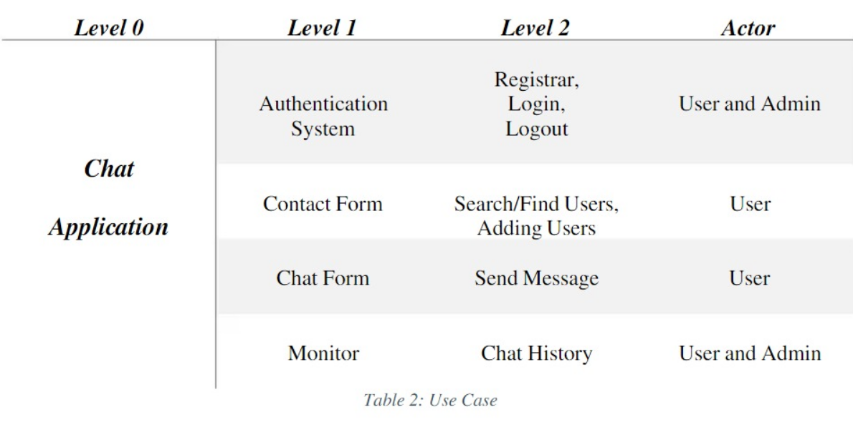

**MODULE 2**

**LITERATURE REVIEW**

**2.1 Introduction**

To study the system being built will require us to study and analyze current systems, in order identify the problems and difficulties with existing system. Included major steps involved in this stage to identify needs users and a study current system to verify the problem. Study of current systems are also benefit to know expected performance by the new system in order meet user requirements. also analysis this information that has been collected and evaluated to help us in build our project.

**2.2 Current System**

Most chat rooms use the current connection by sending messages. Some chat rooms feature the ability to use audio and video to communicate and upload images almost instantly. Most chat rooms require registration and a password. Extent chat rooms allows for recording such as those run by colleges (and usually allows for current and former students only registration). It all depends on who is running the chat room, which monitors, if anyone. Also there are sites that allows people to chat while playing games online .

**2.3 Proposed System**

The project aims to create a chat room for communication and exchange of ideas with each other without having any language barrier. What we want to do is create a chat room to be secure and convenient for all Users.

Equipped with the following benefits:

1. Client can Login through the nickname of the connect.

2. Users can chat in there preferred language.

3. User can see connection’s Presence status (Online/offline).

4. User can hear Buzz sound on receiving new notification.

5. Can choose a theme that looks appealing to you.

**MODULE 3**

**FEASIBILITY STUDY**

Trans-Chat project demonstrates a range of features designed to enhance the user experience and improve the functionality of the Chat Application. To assess the feasibility of this project, we will analyze its technical, economic, aspects.

**3.1 ECONOMIC FEASIBILITY**

The project's economic feasibility involves evaluating the cost of developing and maintaining the platform. This includes expenses related to acquiring necessary software licenses, hosting the application, and ongoing maintenance and support. A cost-benefit analysis should be conducted to determine if the anticipated benefits outweigh the projected costs.

**3.2 TECHNICAL FEASIBILITY**

The implementation of features such as login/logout system, Chat Interface , User online/offline status check , requires technical expertise in web development, database management, and integration of APIs. It is essential to ensure that the required technology infrastructure is available or can be acquired to support the project's implementation.

**MODULE 4**

**TECHNOLOGIES USED**

**4.1 REACT**

React is a JavaScript library for building user interfaces. It is used by many popular websites and applications, including Facebook, Instagram, and Netflix. React is known for its performance, flexibility, and ease of use.

React is based on the concept of components. A component is a self-contained piece of code that renders a specific part of the user interface. Components can be reused and combined to create complex user interfaces.

React is also known for its use of virtual DOM. The virtual DOM is a representation of the user interface that is stored in memory. When the state of the user interface changes, React only updates the parts of the virtual DOM that have changed. This makes React very efficient, especially for large and complex user interfaces.

React is a powerful tool for building user interfaces. It is easy to learn and use, and it is very efficient. If you are looking for a JavaScript library for building user interfaces, React is a great option.

**4.1.1 Why use React?**

Below are a few reasons to opt for React :

* Performance: React is very efficient, especially for large and complex user interfaces.
* Flexibility: React is very flexible and can be used to build a wide variety of user interfaces.
* Ease of use: React is easy to learn and use, even for beginners.
* Community: React has a large and active community of developers who are constantly creating new tools and resources.

**4.2 NODE JS :**

Node.js is an open-source, cross-platform runtime environment that runs JavaScript code outside of a browser. Node.js is built on the Chrome V8 JavaScript engine and can be used to create both server-side and client-side applications.

Node.js is known for its event-driven, non-blocking I/O model, which makes it efficient and scalable for handling large numbers of concurrent connections. Node.js is also popular for its large library of modules, which makes it easy to build complex applications.

Node.js is used by a wide variety of companies, including Netflix, Uber, and PayPal. It is also used to build popular open-source projects, such as Express.js, MongoDB, and Redis.

Node.js has gained significant popularity among developers due to its performance, scalability, and the ability to use JavaScript on the server-side. It has a large and active community, with extensive documentation and a wide range of modules available through NPM, making it a versatile and powerful platform for building web applications and server-side services.

**4.2.1 Advantages of Node Js :**

* **High Performance :**

One of the most important features of node.js is the ability to create lightning-fast apps that produce results in seconds.

The ability to multitask that Node.js provides is extremely beneficial to web apps.

**• Scalability :**

The applications can be horizontally scaled by adding additional nodes to the existing system.

During the vertical scaling of the application, Node.js allows you to add extra resources to single nodes.

As a result, it is extremely scalable and offers a superior alternative to existing JavaScript servers.

**• Easy to Learn :**

Most frontend developers are familiar with JavaScript .

It will be lot easier for them to get started using Node.js on the backend.

It is simpler to understand Node.js, and working with it takes less time.

**• Cost-Effective :**

Eliminates the need for two resource teams, saving time, money, and energy for overall project development.

• **Large Community Support :**

Millions of developers actively contribute to the Node.js community.

To address even the most bizarre development difficulties, anticipate widespread cooperation from development specialists all across the world.

NPM is the world's most comprehensive package manager registry. It includes a number of tools and libraries that you may use right away in your project.

• **Improves Response time and boosts performance :**

Uses fewer resources since it does not spawn more threads.

It improves the responsiveness of your application by dealing with several concurrent users.

**4.3 FIREBASE :**

Firebase is a mobile and web application development platform developed by Firebase, Inc. and acquired by Google in 2014. Firebase offers a variety of services, including:

* Realtime Database: A cloud-based NoSQL database that allows you to store and sync data in real time across all of your users' devices.
* Authentication: A secure and easy way for users to sign into your app.
* Cloud Messaging: A service that allows you to send push notifications to your users' devices.
* Hosting: A service that allows you to host your web app on Google's infrastructure.
* Crash Reporting: A service that helps you track and fix crashes in your app.
* Performance Monitoring: A service that helps you track the performance of your app.
* Remote Config: A service that allows you to change the behavior of your app without having to release a new version.
* Test Lab: A service that allows you to test your app on a variety of devices and configurations.
* App Distribution: A service that allows you to distribute your app to users.

Firebase is a popular choice for mobile and web application development because it offers a wide range of services that can help you build and deploy high-quality applications. Firebase is also very easy to use, making it a good choice for developers of all skill level.

**4.3.1 Advantages of Firebase :**

* Performance: Firebase is very efficient and can handle large numbers of concurrent connections.
* Scalability: Firebase is very scalable and can be used to build large and complex applications.
* Security: Firebase is very secure and uses industry-standard encryption to protect your data.
* Ease of use: Firebase is very easy to use and can be integrated with your existing development tools.
* Community: Firebase has a large and active community of developers who are constantly creating new tools and resources.

**4.4 FIGMA**

Figma is a web-based design tool that allows you to create and collaborate on designs in real time. It is a popular choice for designers of all skill levels, from beginners to professionals. Figma offers a wide range of features, including:

* Vector drawing tools: Figma's vector drawing tools allow you to create precise and scalable designs.
* Text editing tools: Figma's text editing tools allow you to create and format text in a variety of ways.
* Symbols: Figma's symbols allow you to create and reuse design elements across your project.
* Auto layout: Figma's auto layout allows you to create designs that automatically adjust to different screen sizes.
* Plugins: Figma has a large library of plugins that can extend its functionality.
* Collaboration: Figma allows you to collaborate on designs in real time with other designers, developers, and stakeholders.

Figma is a great choice for designers who want a powerful and versatile design tool that is easy to use and collaborate on. It is also a good choice for designers who want to create designs that are responsive and look good on any device.

**4.4.1 Advantages of using Figma**

* Collaboration: Figma allows you to collaborate on designs in real time with other designers, developers, and stakeholders. This can help you get feedback early and often, and it can also help you save time by working on the same design at the same time.
* Ease of use: Figma is very easy to use, even for beginners. The interface is clean and intuitive, and the tools are easy to learn.
* Powerful features: Figma offers a wide range of powerful features, including vector drawing tools, text editing tools, symbols, auto layout, and plugins. These features allow you to create high-quality designs that are responsive and look good on any device.
* Affordable: Figma is very affordable, especially when compared to other design tools. There is a free plan that is perfect for individual designers, and there are paid plans that offer additional features and storage.

**MODULE 5**

**SYSTEM DESIGN**

**5.1 SYSTEM DESIGN**

The process of developing a system's architecture, components, and interfaces to meet end user needs is known as system design. System design is an important consideration for tech interviews. Almost every IT behemoth, such as Facebook, Amazon, Google, and others, conduct interviews that include questions about System Design topics such as scalability, load balancing, caching, and so on. This specially created System Design course will assist you in quickly learning and mastering System Design topics at all levels, from beginner to advanced.

The chat application will allow users to communicate in real time with each other, regardless of their language. The application will use a language translation service to translate messages in real time, so that users can communicate with each other without having to worry about language barriers.

**5.1.1 System Architecture**

The system architecture will consist of the following components:

* Front-end: The front-end will be developed using HTML, CSS, and JavaScript. The front-end will be responsible for displaying the chat interface and handling user input.
* Back-end: The back-end will be developed using Node.js. The back-end will be responsible for handling user authentication, message handling, and language translation.
* Database: The database will store user data, including their usernames, passwords, and chat history.
* Language Translation Service: The language translation service will be used to translate messages in real time.

**5.1.2 User Interface Design**

The user interface design will be simple and easy to use. The chat interface will be divided into two main sections: the message input section and the message output section. The message input section will allow users to type messages. The message output section will display messages that have been sent or received.

**5.1.3 Database Design**

The database will store the following data:

* User accounts: The database will store user accounts, including their usernames, passwords, and email addresses.
* Chat history: The database will store chat history, including the sender, recipient, message, and timestamp of each message.

**5.1.4 Security & Privacy**

The following security and privacy measures will be implemented to protect user data:

* User authentication: Users will be required to authenticate themselves before they can access the chat application.
* Message encryption: Messages will be encrypted before they are sent, so that only the intended recipient can read them.
* Data security: The database will be stored in a secure location and access to the database will be restricted to authorized personnel.

**5.1.5 Deployment & Maintenance**

The application will be deployed to a cloud-based hosting service. The application will be maintained by a team of developers and system administrators.

**5.2 DATA FLOW DIAGRAMS**

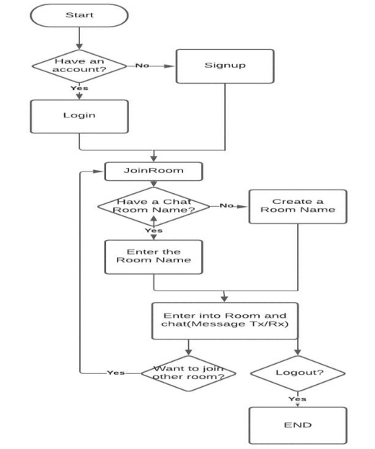

**Fig : DFD 1**

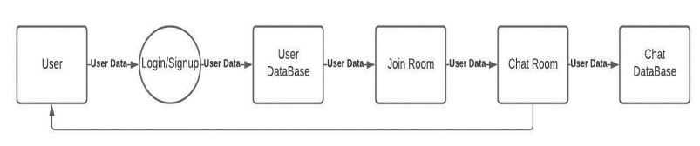

**Fig : DFD 2**

**5.3 USER INTERFACE SNAPSHOTS:**



**Fig : Cyber Punk Theme**

**LOGIN PAGE**

If the user have already account they can login using their username and password credentials .

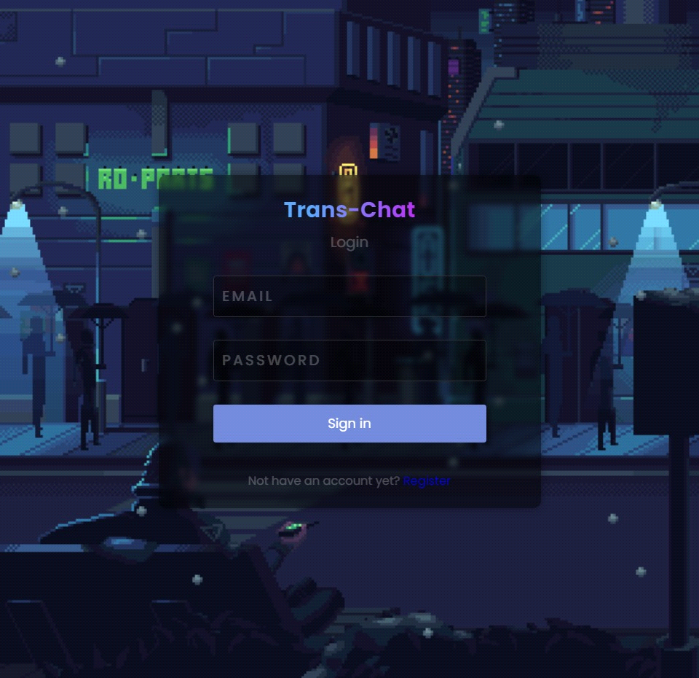

**Fig : Login Page**

**SIGN UP PAGE**

User can create here the account with their user credentials e.g. email, name, password.

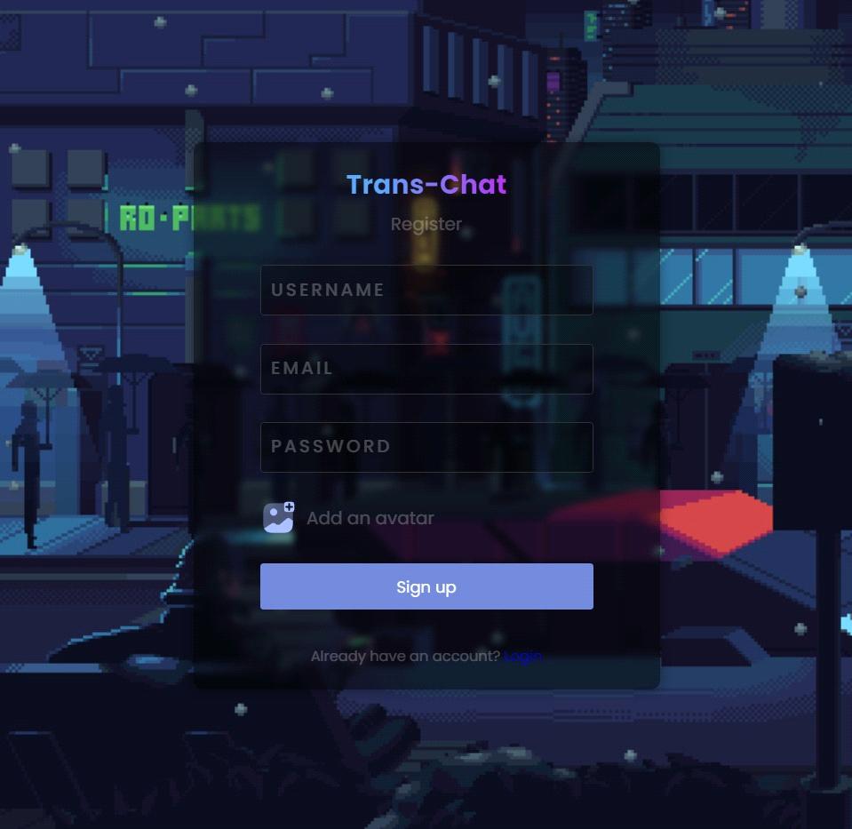

**Fig : Sign Up Page**

**CHAT PAGE**

Chat application is totally responsive and made for every device so every user can use the application easily.

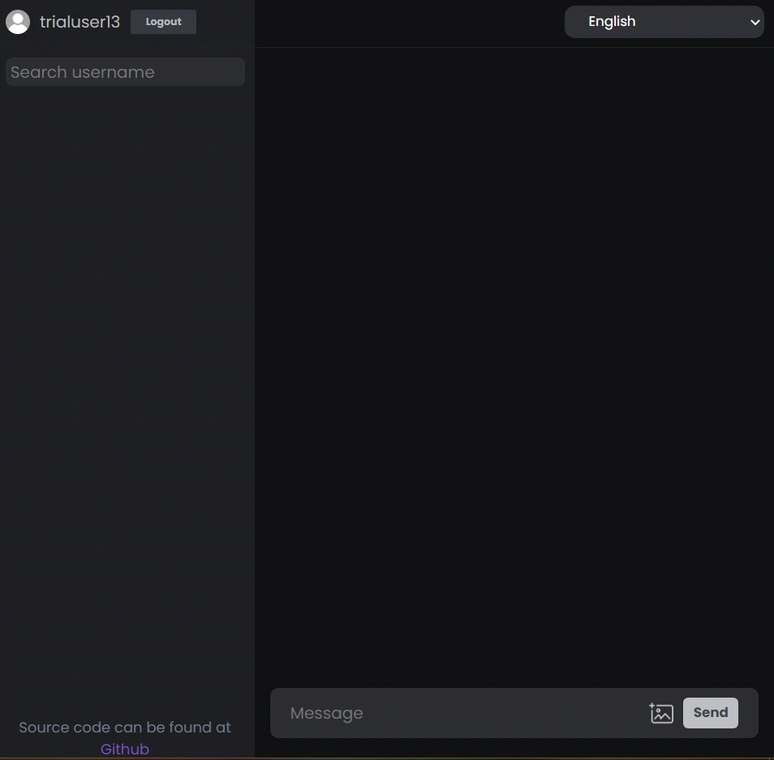

**Fig : Message Input Area**

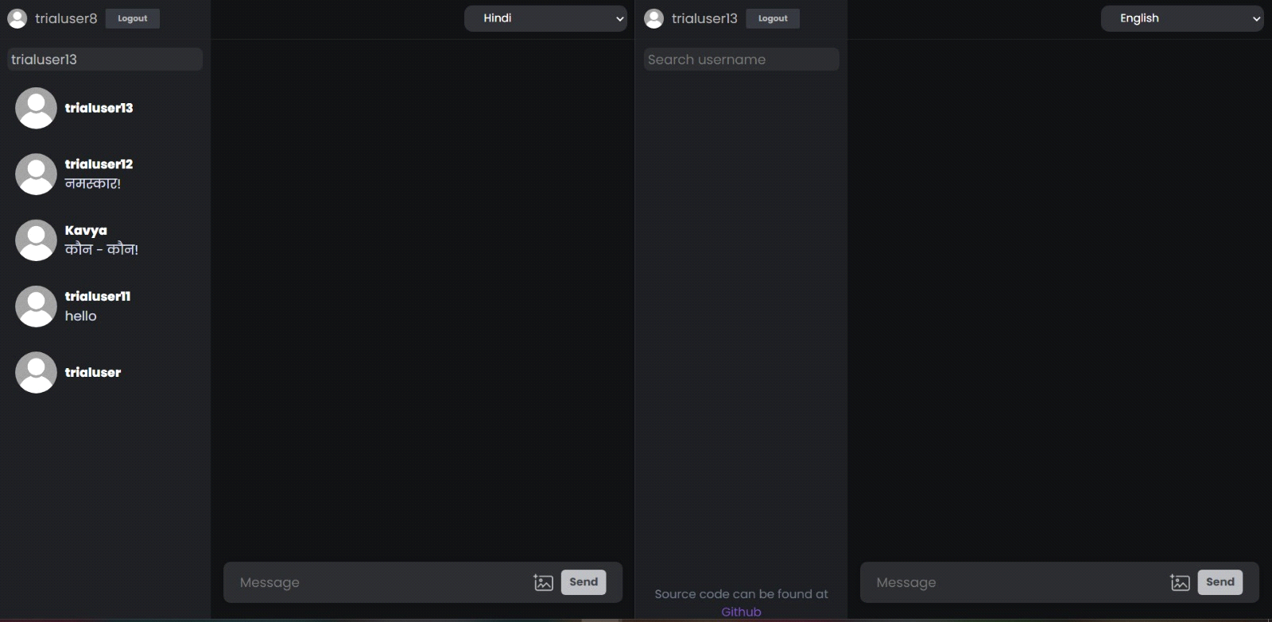

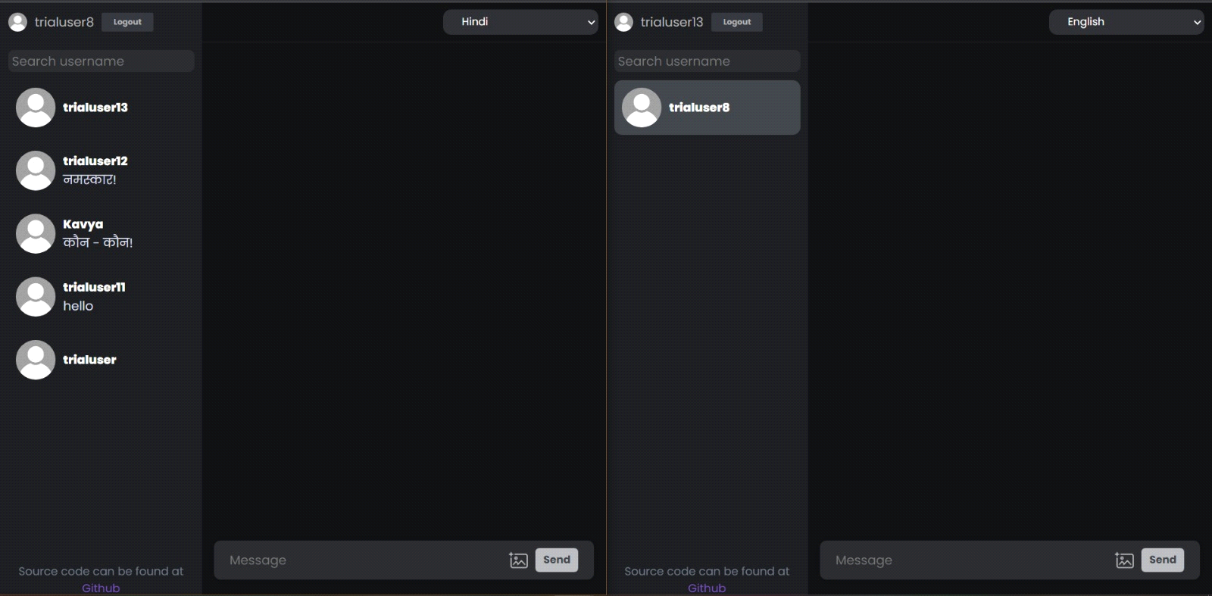

**Fig : Available Users Panel**

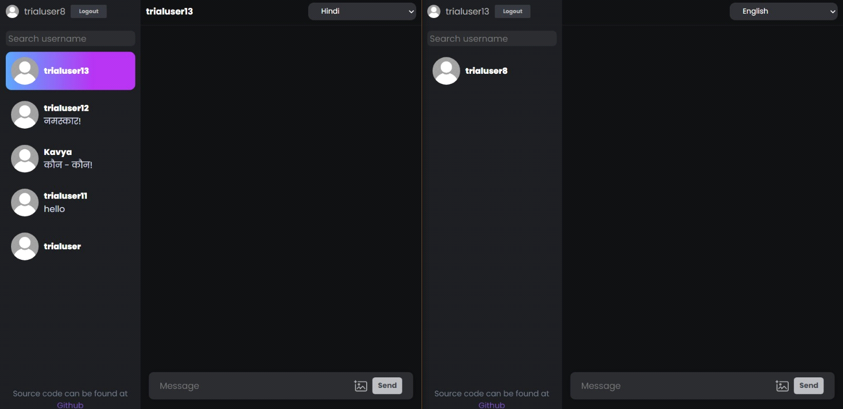

**Fig ; Sender Selected** 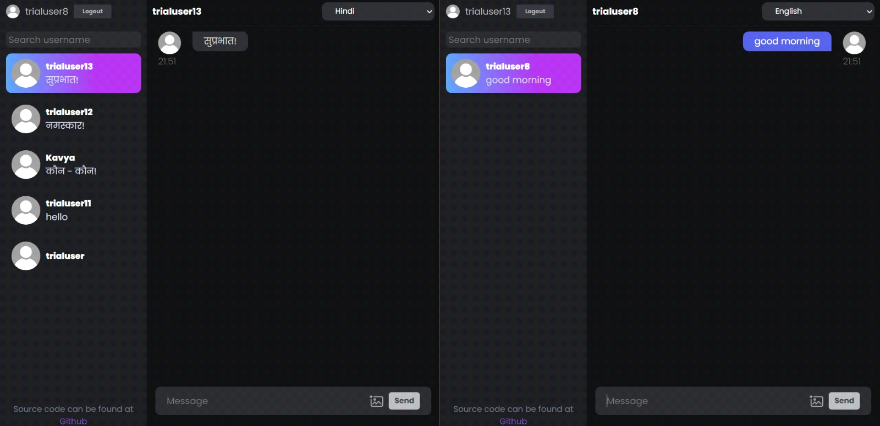

**Fig : Receiver Selected**

Now Let’s talk about the chat message feature, when the user sends any message to the chat, it will be shown at the right side and for the other online users it will shown on the left side as what happens in every other chat application, from this way it’s easy to understand that right side all messages are from user side and left one from other users. See below in the Screen Shot and yes one thing when the user sends the message, all the other users who are present in the chat at that time will get ding sound as the notification of the message.

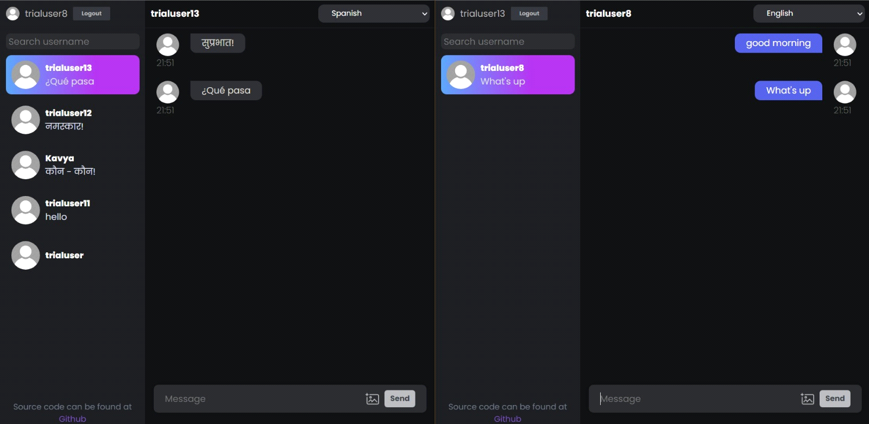

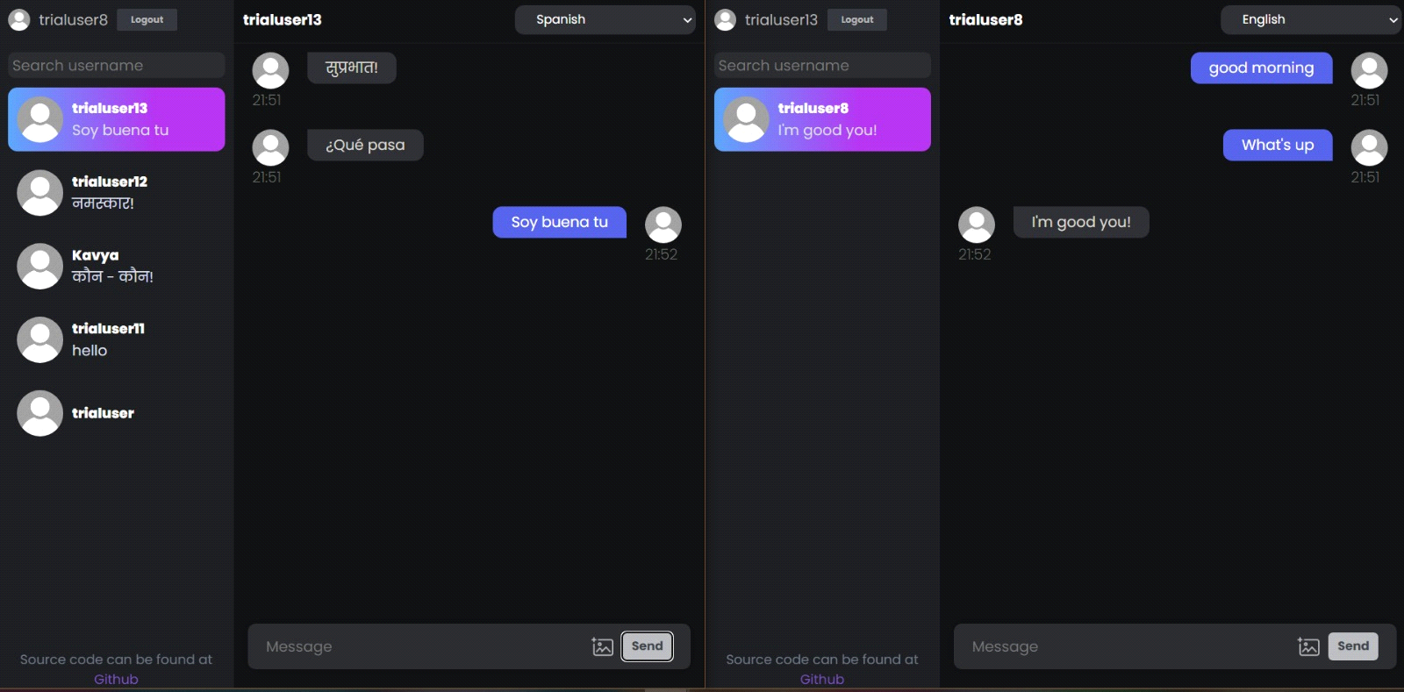

**Fig : Message Sent and Translated on Both The Ends**

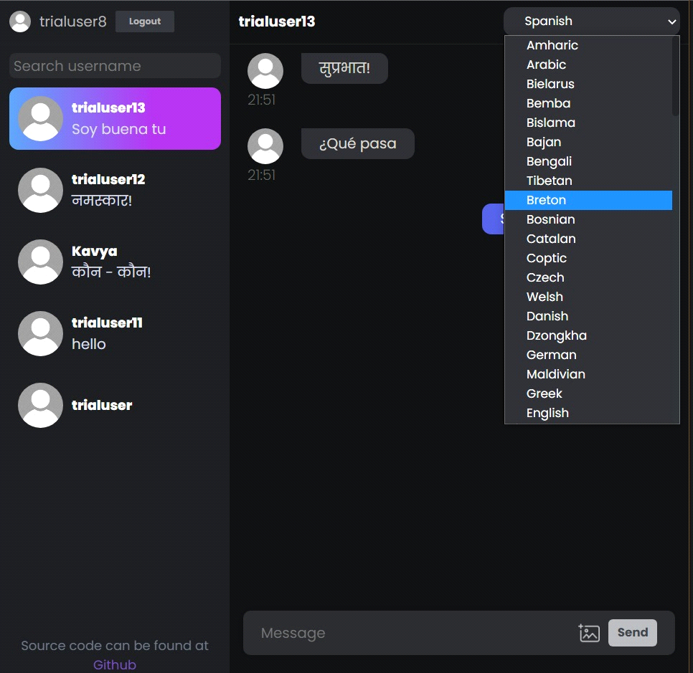

**Fig : Language Selection View**

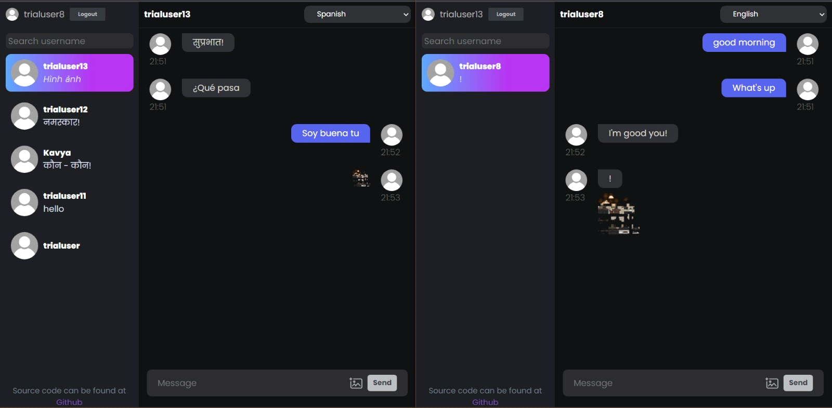

**Fig : Images Sent**

**MODULE 6**

**6.1 TESTING AND MAINTENANCE**

Testing techniques and test cases used-

* **Software Testing:** Software testing is the process of examining software and determining if it performs the duties as intended. Before deploying a software application, software engineers can test it for defects, unfinished functionalities, and incorrect output.
* **Unit Testing:** Unit testing is a sort of software testing in which each and every component of a software application is examined. It examines the modules in a software application for data control, data flow, and whether individual source code units are functioning properly. Unit testing examines the module's functionality and behaviour.
* **Integration Testing:** Integration testing is a sort of testing that evaluates and tests the integration of several modules. During this testing, it is determined whether the various components are properly integrated and fulfilling their intended functions. It allows us to test the software's general functionality as well as the compliance of modules with one another.
* **Black Box Testing:** Testing from the perspective of someone who is unaware of the system's internal workings is known as black box testing. This enables testing of the application in a manner that mimics end-user behaviour and how they would use it. This also aids in the discovery of flaws or defects that the development team may have overlooked. It also allows you to test how people will engage with the app and what kind of experience they will have.
* **Manual testing:** Manual testing is a type of software testing in which test cases are manually conducted rather than utilising an automated tool. All test cases are manually executed by the tester from the perspective of the end user. It determines whether the application meets the requirements specified in the requirement document. To finish nearly 100% of the software application, test cases are created and implemented. Manually created test case reports are also available. Manual testing is one of the most basic testing procedures since it may detect both obvious and hidden software faults. A fault is the difference between the expected output and the output provided by the software. The developer corrected the flaws and passed the code over to the tester to retest.

The different modules of the project were manually tested as and the actual results were compared to the expected results. Thus, the actual results were somewhat near to the expected results.

**MODULE 7**

**RESULTS**

**7.1 RESULTS AND DISCUSSIONS**

The results obtained from a real-time translation chat application can vary depending on the specific implementation and the goals of the application. Here are some common results that can be expected:

**Improved Communication Across Languages**: The primary result of a real-time translation chat application is the ability to facilitate effective communication between users who speak different languages. Users can converse in their native languages, and the application translates their messages in real time, enabling seamless understanding and interaction.

Language Inclusivity: A successful real-time translation chat application promotes inclusivity by allowing users to participate in conversations regardless of their language proficiency. It eliminates language barriers and ensures that language differences do not hinder communication, fostering a more inclusive and accessible environment for users.

Enhanced Global Collaboration: Real-time translation chat applications enable global collaboration by connecting individuals from different linguistic backgrounds. This result can be particularly beneficial for international business negotiations, online communities, or remote teams, as it enables smooth communication and collaboration across borders and language barriers.

Increased Efficiency and Productivity: By providing instant translation capabilities, a real-time translation chat application improves efficiency and productivity in cross-language communication scenarios. Users can communicate more effectively, reducing misunderstandings and enhancing overall productivity in collaborative efforts.

Cross-Cultural Understanding: Real-time translation chat applications contribute to cross-cultural understanding by facilitating conversations between individuals from different cultures and backgrounds. Through translated conversations, users gain insights into different perspectives, fostering cultural exchange and empathy.

Real-Time Feedback and Iterative Improvements: The deployment of a real-time translation chat application allows for the collection of valuable user feedback. This feedback can be utilized to identify areas for improvement, address issues, and iteratively enhance the application's translation accuracy, performance, and user experience over time.

Global Reach and User Engagement: A successful real-time translation chat application can attract a diverse user base from around the world. By enabling communication in multiple languages, the application has the potential to expand its reach and increase user engagement, facilitating connections and interactions among users from different regions.

Data Insights and Analytics: Real-time translation chat applications can gather data on user interactions, preferences, and language patterns. Analyzing this data can provide valuable insights into user behavior, help identify usage patterns, and guide future enhancements and updates to the application.

It is important to note that the specific results and their significance may vary depending on the objectives, target audience, and context of the real-time translation chat application. Regular monitoring, evaluation, and continuous improvement efforts are essential to ensure that the application delivers the desired results effectively.

**MODULE 8**

**CONCLUSION AND FUTURE SCOPE**

**8.1 CONCLUSION**

In conclusion, a real-time translation chat application stands as a powerful and transformative tool for overcoming language barriers and enabling seamless communication across diverse language speakers. By harnessing advanced technologies such as translation services, chat servers, and user interfaces, these applications facilitate instant translation of messages, leading to enhanced global connectivity and collaboration.

The advantages of real-time translation chat applications are substantial and wide-reaching. They empower users to communicate effortlessly in their native languages, fostering inclusivity and promoting meaningful cross-cultural interactions. These applications find practical utility in a range of scenarios, including international business negotiations, online communities, and global customer support.

The system design of a real-time translation chat application encompasses several critical components, including chat interfaces, robust chat servers, powerful translation engines, databases, and seamless integration with external services. By carefully designing the architecture, these applications provide users with a seamless experience, characterized by efficient message delivery, secure authentication, and reliable translation capabilities.

By capitalizing on the strengths of technologies such as React for the user interface and Node.js for the server-side, developers can create real-time translation chat applications that are highly scalable, performant, and responsive. Moreover, the availability of reputable translation services and APIs enhances the accuracy and dependability of translations, ensuring a smooth and reliable communication experience.

The future holds promising advancements for real-time translation chat applications. Ongoing progress in natural language processing, machine learning, and AI will undoubtedly contribute to even more accurate and context-aware translations. Additionally, improvements in user interfaces, voice recognition, and integration with diverse communication channels will further heighten the usability and accessibility of these applications.

In summary, real-time translation chat applications possess immense potential in breaking down language barriers, fostering global communication, and facilitating cross-cultural understanding. As technology continues to evolve, these applications will assume an increasingly crucial role in connecting people from diverse backgrounds, promoting collaboration, and enabling meaningful interactions that surpass the constraints of language.

**8.2 FUTURE SCOPE**

The future scope for real-time translation chat applications is quite promising. As technology continues to advance, there are several areas where these applications can evolve and expand:

Improved Translation Accuracy: Ongoing advancements in natural language processing, machine learning, and AI will lead to more accurate and nuanced translations. As these technologies continue to progress, real-time translation chat applications can leverage them to provide highly precise and context-aware translations, even for complex language structures and idiomatic expressions.

Multi-Modal Communication: Future real-time translation chat applications can extend beyond text-based communication and incorporate other modes of communication, such as voice and video. This would enable users to have spoken conversations in different languages, with the application translating the conversation in real-time. Integrating speech recognition and synthesis technologies will be crucial in achieving this advancement.

Real-Time Transcription: Real-time translation chat applications can expand their capabilities to include real-time transcription of audio and video content. This would be particularly useful in scenarios like live conferences, lectures, or interviews, where users can follow along with the translated text in real time.

Customization and Personalization: Future applications may allow users to customize translation preferences according to their language proficiency, dialects, or personal preferences. The ability to fine-tune translations and adapt them to individual communication styles would enhance the overall user experience.

Integration with Internet of Things (IoT): With the rise of IoT devices, real-time translation chat applications can integrate with smart home devices, wearable technology, and other connected devices. This would enable users to have seamless translated interactions with their devices, expanding the scope of real-time translation beyond traditional chat interfaces.

Virtual Reality (VR) and Augmented Reality (AR) Integration: Incorporating VR and AR technologies into real-time translation chat applications can provide immersive language learning experiences and facilitate real-time communication in virtual environments. Users can interact with others from different linguistic backgrounds and experience translated conversations in a more engaging and interactive manner.

Enhanced Security and Privacy: As real-time translation chat applications handle sensitive user data, ensuring robust security measures and privacy protections will be of paramount importance. Future developments should focus on implementing secure encryption, data anonymization, and stringent privacy controls to instill user trust and confidence.

Integration with Social Media and Online Platforms: Real-time translation chat applications can extend their reach by integrating with popular social media platforms, messaging apps, and online collaboration tools. This would enable seamless translation of conversations across various platforms, expanding the global communication capabilities of these applications.

These are just a few potential directions for the future scope of real-time translation chat applications. With continued advancements in technology, the possibilities for improving translation accuracy, expanding communication modes, and integrating with emerging technologies are vast. The focus will be on enhancing user experience, enabling seamless cross-language communication, and fostering global connectivity.

**MODULE 9**

**REFERENCES**

[1] Ian V. Sandoval CLIENT/SERVER TECHNOLOGY, ,2005

[2] Waleed Farah,DEVELOPING A CHAT SERVER,Fall 2000

[3] Rahman, M. M., Development of Dialogue Based Object Oriented Client/

server Applications On the Internet: An Online Interviewing System, AIT

Masters Thesis CS- 98-17, 1998.

[4] Berson, Alex., Client-server architecture. McGraw-Hill, 1994.

[5]Chat Rooms,

http://en.wikipedia.org/wiki/Chat_rooms,2002

[6] Kendall & Kendall,Systems Analysis and Design

,Sixth Edition,2005 Pearson Prentice Hall

[7] McGraw-Hill Osborne Media ,The Complete Reference JAVA 2 fifth

edition, 2002

[8] Ian Darwin, Publisher: O'Reilly, Java Cookbook (e-book), First Edition June

2001

[9]Disadvantages of Using Skype ,http://www.ehow.co.uk/ list_5907068_ disad_

vantages-using-skype.html

[10]Advantages and Disadvantages of Skype ,http://wadams6.blogspot.com

/2011/02/movie-platoon.html

[11] System Development Life Cycle (SDLC) Methodologies ,http:// www .slepi

.net/blog/system-development/system-development-life-cycle-sdlcmethodologies.html

[12] Ishaya. G et al (2010) towards an efficient information systems development

process and management: A review of challenges and proposed strategies,

software engineering and publications

[13]Software Engineering, 8th Edition, Sommerville , ISBN: 0321313798 , June

4, 2006

[14] Socket Communications, http:// www.oracle.com/ tech network/java/socket140484.html

46

[15]Programming with JAVA, Java Development Kit, Safari Books Online is a

digital library

http://my.safaribooksonline.com/book/programming/java/9788131720806

[16] This document was prepared by National Center to Improve the Tools of

Education, U.S. efface of Special Education Programs.

http://idea.uoregon.edu/~ncite/documents/techrep/tech01.html